

**Table of contents**

INTRODUTION 2

I. Company’s Key Points 3

II. Product and Service Specification 4

A. Product Specification: 4

B. Service Specification: 5

II. Startup Foundation 7

III. Market Research 7

IV. Target Customers 11

V. Promotional Strategy 12

VI. Organization and Management 14

VII. Competition 16

VIII. Financing & Investments 17

IX. Timeline Roadmap 18

X. Future Projects 19

CONCLUSION 19

# INTRODUTION

In a world where travel is associated with freedom and exploration, the heavy burden of luggage has continued to be a source of frustration for contemporary explorers. Travel clothing conventions are ready for change, from confusing checked baggage prices to the tiresome process of lugging suitcases through interminable airport hallways,

Presenting **FlyFit**, the cutting edge of traveling light.

Imagine stepping off the plane with nothing but the essentials, free from the oppressive hold of excessively heavy luggage. FlyFit welcomes the modern era of travel by providing a cutting-edge wardrobe rental service that ships clothes right to your location. Your journey with us is about the encounter, not the extravagance.

Our goal is to release tourists from the financial and physical burden of carrying heavy bags so they can have a journey that is as unrestricted as the countries they visit. FlyFit completely alters the way you move in addition to how you pack. It's a novel approach to travel for the environmentally concerned and eco-savvy generation, making discovery easy, fashionable, and most crucially, unrestricted. Welcome to FlyFit, where your wardrobe for travel is as endless as your desire to explore.

# I. Company’s Key Points

1. The possible customer interacts with an online system, might that be either a website or a downloadable application in the two main operating systems, ANDROID and IOS.

1. Whether or not the customer has an account, he will have the option to select its desired destination within Continental Europe. We have decided to launch our service in this region for several reasonable reasons:

* + Firstly, Continental Europe serves as a major hub for travelers and explorers from all corners of the globe, offering a wealth of experiences and attractions to explore.
  + Secondly, our choice is influenced by proximity, as it is where we are based, making it more convenient for us to operate effectively.
  + Lastly, financial considerations played a role in our decision. The economic opportunities in Continental Europe make it a strategic choice for our service.

1. Once the customer has chosen its destination, he can further customize his/her experience. He will have the flexibility to select its preferred pickup location, whether it is directly at the Airbnb, Hotel, Hostel, or even at the airport/train station. There will be a list of several airports and strategic train stations located all over the continent to ensure that customers will have access to personal lockers where the clothes will be kept and protected.

1. After specifying the retrieval location, the customer will be able to browse our diverse collection of rental clothes, all offered at competitive prices. Then, he will choose the start and end dates for the rental, tailoring it to its trip's duration.

1. Once the customer made his selections and set his rental period, he can conveniently pay the rental costs. When the journey comes to an end, he will simply return the clothes at designated locations, either in the airport or at strategically placed train stations.

# II. Product and Service Specification

## A. Product Specification:

Our product selection at FlyFit has been carefully chosen to satisfy the wide range of demands of contemporary travelers. We make sure that our customers are prepared for every event and adventure by providing a wide selection of apparel goods.

Let us look at the clothing line:

***Seasonal Categories:***

**Summer**: Lightweight linens, breathable cotton, and swimsuits for the sun-seekers.

**Spring**: Versatile clothes for the ever-changing weather.

**Winter**: Insulated coats, warm knitwear, and accessories to brave the chill in comfort (clothes endure to cold weather while feeling comfortable).

***Occasion Categories:***

**Casual (Daily Use)**: Comfortable and stylish options perfect for exploring cities, dining out, or day-to-day activities.

**Formal (Special Occasions)**: Elegant dresses, suits, and fine garments for business events, weddings, or important evenings.

**Adventurous (For Expeditions, Climbing, Sports)**: Durable and performance clothes which are worn for hiking, skiing, or any outdoor adventure.

**Variety of Clothing**: From essential basics to specialized wear, including shoes, trousers, shirts, t-shirts, dresses, jackets, coats, and all sorts of hats. Each category is thoughtfully selected to provide different styles and preferences.

**Sizes and Inclusivity**: Embracing the beauty of diversity, FlyFit stocks a comprehensive range of sizes.

**Second-Hand Use**: For the eco-conscious traveler, FlyFit provides a ‘Green Selection’ as well of high-quality second-hand clothes.

**Brands**: In term of brand possibilities, at the beginning we would consider non-recognizable branded products as it would imply a huge increase in costs. However, if the business attracts more customers and it allows an increase of the budget, then we would partner with a spectrum of brands, from renowned international labels to local artisan collections, providing a selection that balances quality with ethical and sustainable production practices.

## B. Service Specification:

The service delivery is equally or even more important than the products selection process. To make possible what we envision, it is a must to surround ourselves with experts in the following areas:

a) **Logistics:**

* **Distributed Inventory:**

Instead of a centralized warehouse, we consider developing a distributed inventory which can lead to faster deliveries and reduced shipping costs. At the creation of Flyfit, we would first implement a prototype and later a Minimum viable product (MVP) we would start operating in **Paris, France**. From the capital, we would only have one inventory, our own places. However, if the business grows significantly, we have already considered the four main countries where we would be interested to rent or build our future inventories:

**Switzerland, Poland, Andorra, and Kosovo.**

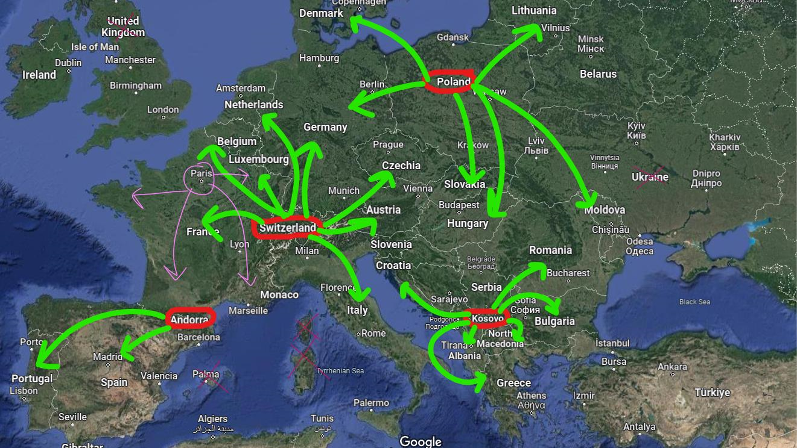

* **Supply Chain Management**:

We would need to develop relationships with reliable suppliers and manufacturers. Ensure they can provide the necessary stock levels and adhere to quality and sustainability standards. During the first steps, we would consider Asian manufacturing companies, especially

Indonesian and Chinese ones due to their cost reduction in items for larger orders.

* **Shipping Partners**:

As we grow and attract more customers, we would partner with trustworthy and reputable shipping, courier services and local suppliers that have extensive coverage across Europe and the corresponding cities. We would take into consideration their costs, delivery times, and track record for reliability. At the beginning of this odyssey, and as we would be operating from Paris, we would utilize the national’s French courier system called Laposte.fr or a local supplier, which would offer us competitive prices, delivery times as well as tracking order possibilities.

* **Insurance:**

In case of not delivered, damaged, stolen, or lost items within the product selection made by the customer, and after understanding the problem, considering which legal procedure to follow, and conducting the appropriate research, we would be willing to refund completely the costs.

b) Customer Service:

As more customers become interested in our company, we would set up a responsive customer service system, a quality control procedure and make efforts to show the sustainable & ecological commitment that resonates in our values.

* **Contact Support**:

We would create a responsive customer service system that handles inquiries, troubleshoot delivery issues, and manages any customer complaints regarding logistics or provides any information related to sustainable commitment and ethical practices of data.

* **Quality Control**:

Within our website page or application, it would be published, alongside with shipping timing and prices information, the quality control procedure system established to ensure that all items are cleaned and inspected before and after each rental, if not, we withdraw them from the service.

c) Sustainability Practices:

The environmental perspective must be considered when it comes to product selection and service delivery. To portray our values within Flyfit, we would consider electric vehicles or system (drones) to deliver on time our products to customer’s selected destination as well as packaging solutions.

* **Delivery systems**:

With the progress in efficiency of electric vehicle batteries, we would seek shipping partners that are transitioning or currently using vehicles powered by renewable energy solutions to deliver our products.

* **Packaging Solutions**:

As envisioned, we would invest in durable and reusable packaging that protects clothing during transit and aligns with our personal beliefs and values to prove the company sustainability approach.

# II. Startup Foundation

We would first start with the creation of a First Prototype, which is a basic version of the wardrobe rental service, paired with Company Formation involving business registration, acquiring necessary licenses, and establishing legal and accounting frameworks. The next step is the launch of the First MVP (Minimum Viable Product), featuring a functional platform with efficient logistics, basic inventory management, and a system for collecting customer feedback. The focus then shifts to acquiring First Customers, targeting specific events and locations to demonstrate service versatility.

1. Barcelona's Mobile World Congress
2. Montreal's StartupFest
3. Vietnam Business Summit in Hanoi

# III. Market Research

Combining the world of air travel and clothing rental, we have looked closely at the numbers on both areas, to show you where the opportunities lie in our business. The Market Research for FlyFit encapsulates several strategic elements based on the following key elements:

* **Global Market**: We highlight the trend of increasing travel frequency and a shift towards minimalist travel, suggesting a rising market for services that support light travel.
* **Direct Competition**: We have Identified key competitors such as Ninja Koten, Any Wear, and Anytime, however we haven’t had access to their sales figures and market share to gauge FlyFit's competitive landscape.
* **Suppliers and Partnerships**: We realise the importance of partnerships with clothing brands and transportation services for convenient clothing pickup and return.

**Sales Goals**: After completing the first MVP, realistic sales benchmarks, and market share targets for FlyFit could be as follows:

1. Monthly Sales: We aim for a progressive scale, starting with a modest target in the first few months post-MVP. For instance, we target 50 rentals in the first month, with an increase of 10% month-over-month as the service gains traction.
2. Weekly Sales: If monthly targets are 50 rentals, this translates to approximately 12-13 rentals per week. Adjust weekly targets based on seasonal demand and marketing initiatives.
3. Annual Sales: By the end of the first year, we aim to achieve 600-700 total rentals, considering the compounded monthly growth.
4. Market Share Targets: We begin with a small, achievable market share target, such as 1-2% of the local travel wardrobe rental market, and plan to grow it by 0.5% each quarter, reassessing quarterly based on performance data and industry trends.

These targets should be aligned with marketing efforts, operational capabilities, and overall market conditions, and be flexible to adjustment based on actual business performance and feedback collection included within the platform and social media.

Starting off the with the clothing rental market:

**Global Apparel Rental Market Revenue From 2019 TO 2026:**

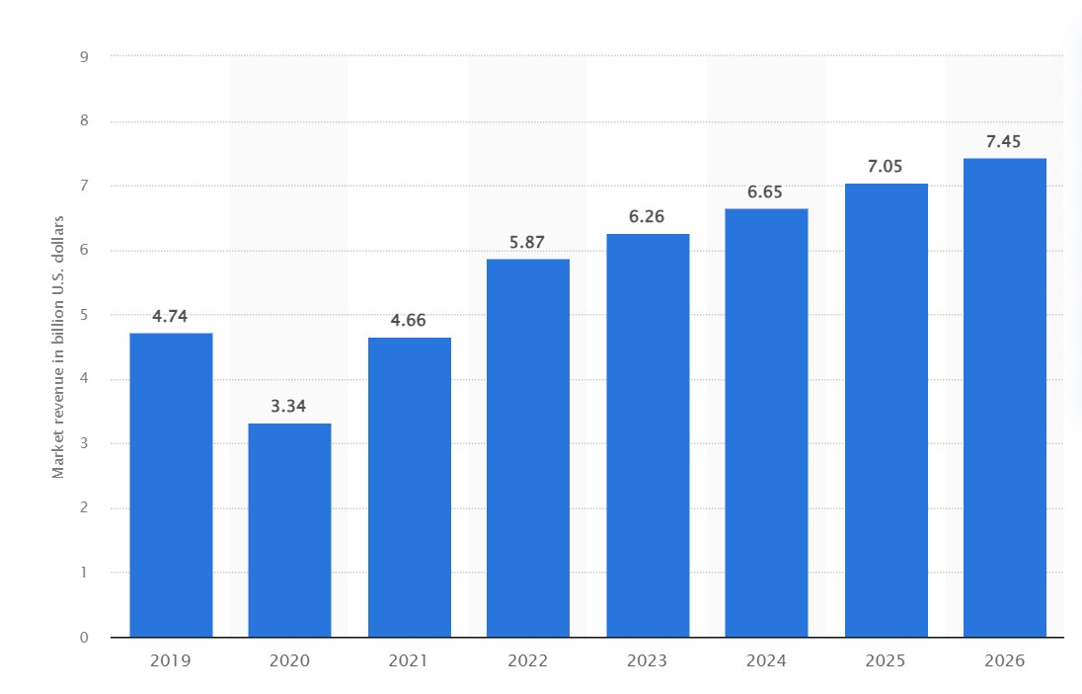

This bar graph displays a growth trend in the rental clothing market revenue from 2019 to 2026. The only noticeable dip was in 2020, and that is due to the COVID-19 pandemic.

The market overall trend, however, shows steady climb, going from $3.34 billion dollars to over $7.4 billion, suggesting a positive outlook for the industry.

**Global Online Clothing Rental Market Share by End-User IN 2021:**

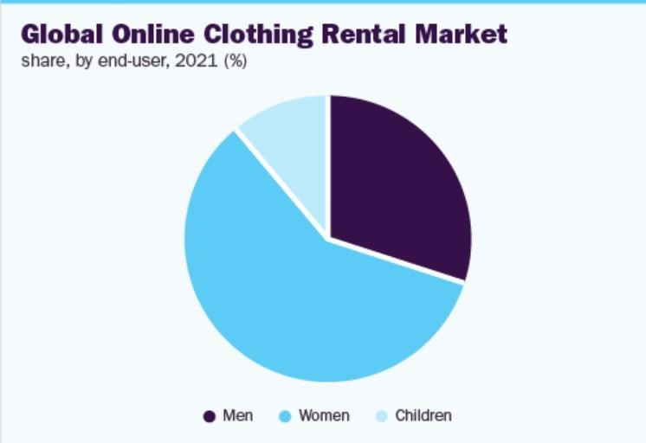

The pie chart illustrates the global online clothing rental market share in 2021 by consumer demographics. It clearly shows women leading with a 59.13% share in market revenue, followed by men and then children.

This representation highlights the potential clientele base, which is quite diverse, and this diversity offer us a chance to reach more customers and grow our business.

**Online Clothing Rental Market Share by Segmentation From 2017 TO 2030:**

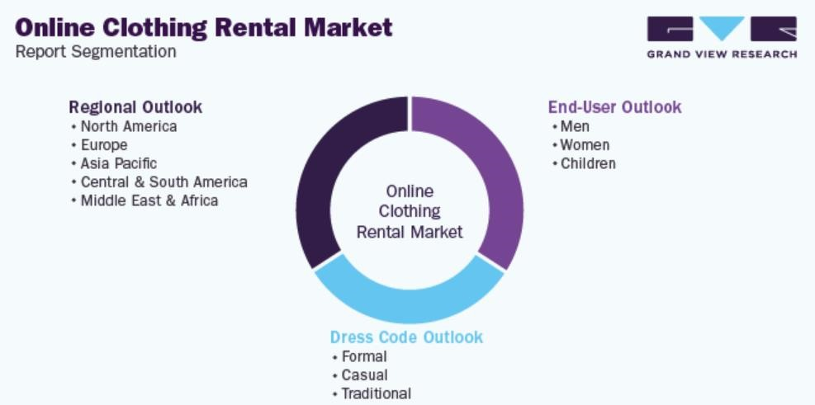

This report’s analysis segments the market into three categories: regional outlook, dress code outlook and end-user outlook.

Regionally, North America is anticipated to lead the market share, with Europe and Asia-Pacific trailing behind. Given our strategic position, this indicates a potential growth in the future.

In terms of dress code, formal wear is noted as the most popular among customers, followed by casual wear. It highlights the importance of catering to the diverse clothing needs within the customer base. We now turn our attention to the Aviation Sector:

**Aviation Market Revenue From 2020 TO 2030:**

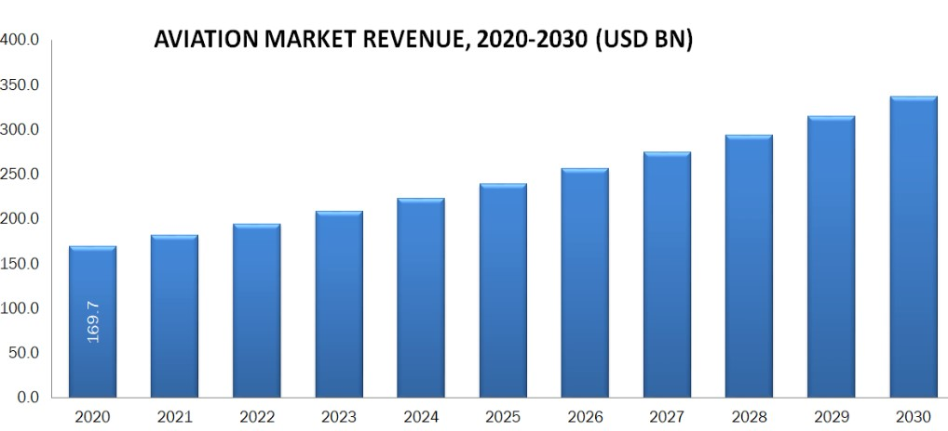

The bar chart illustrates the aviation market revenue from 2020 to 2030 in USD billion.

There is a significant increase over the years, with a revenue of 169.7 billion predicting a market size of over 340 billion, reflecting the market's long-term growth, as well as the expansion of our customer’s base.

**Online Clothing Rental Market Share By Segmentation From 2017 TO 2030 :**

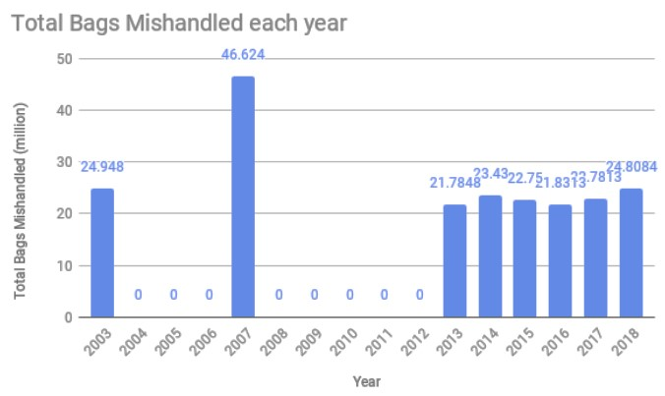

The bar chart shows the total number of bags mishandled each year from 2003 to 2018. You can notice a slight fluctuation from the year 2013 to 2018, as the number of mishandled bags ranges from 21.78 to 24.80 million.

While this graph suggests improvements in baggage handling processes over the years, The issue persists.

**Online Clothing Rental Market Share by Segmentation From 2017 TO 2030:**

This chart presents carbon emissions from aviation by world region, measured in million metric tons of CO2 equivalent for the year 2019 and projected for 2050. It shows North America with the highest emissions in 2019, with an increase in the future making it a stable leader, followed by Europe with 232.2.

This highlights the environmental impact of aviation and may point to the need for sustainable practices in the industry.

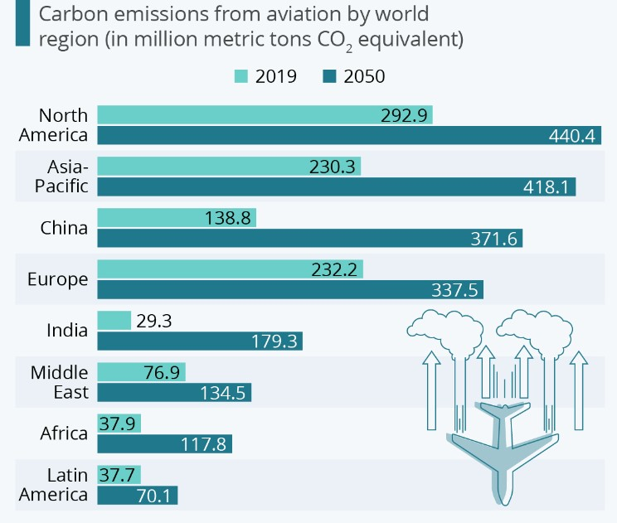

**Summary:**

These graphs were chosen to illustrate that entering the clothing rental industry is a strategic plan since all predictions are bright.

While the aviation industry is a flourishing industry as well, it still faces challenges like carbon emission and mishandled bags.

These presents a prime opportunity for a company like ours, to step up with the ideal service and a convenient solution.

# IV. Target Customers

FlyFit’s service is tailored for a dynamic range of individuals, united by their love of travel and a shared value for convenience, sustainability, and style. Our ideal customers span several demographics: **Eco-Conscious, Budget-Savvy, Business Travelers, Digital Nomads, Tourists, Adventure Seekers, Professionals, Fashion-Forward Travelers, Event Attendees.**





**Eco-Conscious Travelers**

These are individuals who prioritize sustainability in their travel choices. They prefer to reduce their carbon footprint and support services that align with their environmental values. FlyFit's rental model and second-hand clothing options resonate with their green lifestyle.

**Budget-Savvy Tourists**

Cost-aware explorers who aim to minimize travel expenses are a key demographic. By using FlyFit, they can save on baggage fees and avoid the high costs associated with purchasing a diverse travel wardrobe.

**Business Professionals**

Corporate travellers who frequently move between cities for work and need to maintain a polished appearance without the hassle of carrying luggage. FlyFit offers a range of formal wear that can be delivered directly to their accommodation or meeting location.

**Minimalist Backpackers and Digital Nomads**

Individuals who travel with minimal belongings for extended periods. They appreciate the ability to rent clothing as it allows them to pack light and move freely.

**Adventure Seekers**

Outdoor enthusiasts who engage in activities like hiking, skiing, or surfing. They require specialized attire that might be used infrequently, making rental a practical choice.

**Event Attendees & Fashion-Forward Travelers**

Those traveling for specific events like weddings, conferences, or festivals, who require types of clothing for a short duration.

Style-conscious individuals who wish to experience the latest trends and local fashions without the commitment of purchase.

# V. Promotional Strategy

**a) Product:** Flyfit is an online service that offers the convenience of renting a set of clothing anytime you want to travel. This service is perfect for those who find outfit selection challenging, who are too lazy to pack, or who simply prefer not to deal with the burden of heavy luggage.

With just a few clicks, your order will be confirmed and the nearest FlyFit hub will start preparing you order for a quick delivery.

Our product range is diverse, covering seasonal as well as dress-code categories, always in line with the latest fashion trends.

**b) Place:** Our service will be available across Europe; you can access it through our website or mobile application. Operating with a B2C (Business to Customer) model, we focus on directly reaching our customers, offering them a tailored experience.

**c) Price:** To provide an idea of our pricing, we have included a table below with four examples:

**Set’s Name Products Price**

|  |  |  |
| --- | --- | --- |
| **The Weekend City Break** | **Pair of jeans + pair of casual t-shirts + one dress shirt + lightweight jacket + pair of sneakers** | **30€ for the weekend** |
| **The Business Trip** | **Formal suit / Business Dress + Pair of formal shirts / blouses + pair of formal shoes + light coat** | **40€ for up to 3 days** |
| **The Adventure Explorer** | **Waterproof Jacket + Hiking pants + moisture-wicking t-shirts + fleece pullover + hiking boots** | **35€ for up to 4 days** |
| **The Weeklong Vacation** | **3 pairs of shorts + 4 casual t-shirts + two evening wear outfits (like a summer dress or khaki pants with a polo shirt) + a swimsuit + pair of sandals + pair of**  **dress shoes** | **50€ for a week** |

You may observe that our prices are highly affordable, and this is attributed to our strategic supply approach. We collaborate with Indonesian & Chinese suppliers who have a quantity-based pricing system, whereas the more you order, the lower the unit price becomes. This allows us to not only offer competitive prices but also generate profit from this advantageous arrangement.

**d) Promotion:** Our promotional strategy consists of leveraging the influence of social media:

We plan to exploit TikTok's popularity among younger users with engaging short videos, that will demonstrate how FlyFit's service is

user-friendly while highlighting the benefits it offers.

We will expand our audience through Facebook by targeting groups with shared interests, like travel enthusiasts and those interested in sustainable lifestyles.

We are going to use Instagram stories and visually appealing contents to showcase a wide range of clothing options and highlight the convenience of traveling luggage-free.

We also have among our strategy methods:

 We will be Partnering with travel and fashion influencers who embody the essence of FlyFit. They will share their experiences with their followers, providing an authentic testimonial. This will enhance our customer base and credibility.



To enhance FlyFit's online presence and expand organic reach, we plan to incorporate travel and fashion-related keywords and optimize on-page elements. This will help up increase visibility and engagement.



We will introduce a rewards program for regular customers, offering exclusive discounts and early access to new collections.

# VI. Organization and Management

Since the goals of the company are hard to attain, at the beginning of its creation we would dispense with having actual employees for the Startup as we would be working the team members on itself. As we are not capable of solving every single problem that might come on the way, we would be cooperating with friends and family which could provide help and advice. For instance, when it comes to creating the Flyfit platform, which includes the website and/or mobile application, as well as managing the budget and advertising, we plan to collaborate with acquaintances (friends/family) who possess expertise in computer science, economics, and digital marketing.

Nevertheless, as the business gains traction, we would need to define the following departments and roles:

* *CEO (Chief Executive Officer)*
* **Strategic Leadership**: The person in charge and who establishes the company’s vision and strategic direction.

* **Investor Relations**: The CEO would be engaging with current investors and attracting new funding.

* **Brand Ambassador**: Serving as the face of the company, representing FlyFit at major events and in the media.

* **Decision-Making**: Making high-level decisions about policy and strategy.
* *COO (Chief Operating Officer)*

* **Operations Management**: The COO would be overseeing the day-to-day operations to ensure company efficiency.

* **Supplier Relations**: This person would also need to have social skills to develop, maintain and create relationships with clothing suppliers.

* **Logistics Oversight**: The COO would also manage partnerships with shipping companies to ensure timely delivery.

* **Customer Service Excellence**: He/she would ensure implementing high standards for customer experience and addressing any service shortcomings.

* *IT Department: Web Development and Maintenance Team*
* **Web Service Creation**: Initially, the website/application could be managed by friends computing engineers, then this could be contracted out to a specialized web development agency to build a robust, user-friendly platform.

* **Ongoing Web Maintenance**: Once the MVP (Minimal Viable Product) is launched, it could be considered to hire an in-house web developer or small team responsible for the maintenance and update of the web service, including a UI/UX designer to ensure the website remains user-friendly and up to date with the latest trends and technologies.

* **Customer Support:** Besides including in the platform all the information related to shipping time, countries in which we operate, available products, quality control procedure and the insurance policy, we would publish a contact support page allowing customers to submit any complain, advice, recommendation, or feedback. There would be a dedicated team within IT to provide support for customers.
* *Corporate finance and legal: Clothing Procurement Specialist*

Initially we would need to manage these tasks on our own, however it wouldn’t take too long until we need professional support.

* **Supplier Sourcing:** This team would identify and partner with clothing brands and manufacturers that align with FlyFit's quality standards and price points.

* **Inventory Management**: As well, they would need to manage different inventories to ensure that a wide range of sizes and styles are available to meet customer needs.

* **Sustainability Focus**: By analyzing the possible suppliers, the team would ensure that the clothing procurement strategy aligns with the company’s sustainability values and ethics.

* **Finances Management**: The most important task would be budgetary control and financial management.

* *Logistics Department: Shipping and Logistics Coordinator*

Once again, at the initial phase, we would contact ourselves directly with the possible suppliers and shipping partners to obtain all relevant information of their services, but at some point, we would need to delegate control to the appropriate team.

Their main roles would be:

* **Shipping Partnerships**: Establishing and maintaining relationships with global and local shipping partners to ensure efficient delivery and return of rented garments.

* **Logistics Planning**: Planning the most cost-effective and timely routes for clothing delivery and return.

* **Quality Assurance**: Ensuring that the packaging and presentation of shipped items meet FlyFit’s standards.

# VII. Competition

No direct competitors were identified when assessing FlyFit's competitive landscape in Europe. However, we were able to identify three indirect competitors. In the following overview, we will briefly discuss these competitors and how we leveraged their limitations to our advantage.

***Concept:*** The first competitor is AnyWear, AnyWhere. It is a trial program offered by Japan Airlines JAL. It is available exclusively for travelers selecting JAL to travel with and offers a limited collection of clothing.

***Inconvenience:*** Three significant inconveniences AnyWear, AnyWhere face are: A limited reach tied to exclusivity for JAL travelers, a lack of accessibility for users of other airlines, and a narrow focus displayed in a restricted clothing collection.



***Concept:*** The second competitor is Ninja Kotan. It is a Japan-based travel clothing

rental service that caters to the Japanese population, providing carefully selected clothing collections for travelers.

***Inconvenience:*** While they do provide a quick shipping, they face a **One-Destination Limitation,** limiting its availability to a single travel destination, a **restricted wardrobe selection**, offering limited clothing choices, and potential **Style Divergence issues**, as the available clothing may not align with diverse fashion preferences, impacting its appeal in the competitive market.

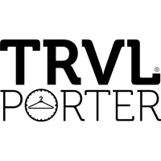

***Concept:*** The third competitor is TRVL PORTER, a US service that rents out travel clothes, focusing on personalized styling and luxury.

***Inconvenience:*** TRVL PORTER encounters challenges including **limited appeal** for budget-conscious travelers, **constrained versatility** in clothing offerings, and **geographic limitations** that hinder accessibility to a wider audience.

For FlyFit, we carefully considered the shortcomings of these services. Our approach includes:

Global Availability + Inclusive Selection + Style Convergence + Sustainability + Competitive prices

**SWOT Analysis**:

Nonetheless, we encountered some challenges by applying a SWOT analysis approach. FlyFit's SWOT analysis underscores its innovative approach to travel through a clothing rental service, which is enhanced by an accessible digital platform and strategic location partnerships. The challenge lies in educating the market about this novel service and managing the intricate logistics it aims, including ensuring compliance with the return policy to mitigate losses. Opportunities for growth are robust, particularly with the rising trend in sustainable travel and potential for international expansion. However, FlyFit must navigate competitive threats from established travel brands and adapt to changing regulations that could affect operations.

# VIII. Financing & Investments

FlyFit is considering four main financing approaches:

* Crowdfunding: Engaging the community to raise funds by showcasing FlyFit's innovative business model and growth potential.
* Loans: Securing financial loans, such as the "prêt à la création d'entreprise" (PCE) for businesses under three years old and the unsecured "prêt d'honneur."
* Grants: Obtaining funds through the French Tech "Emergence" Grant for up to €90k, Tech Seed Fund between €50-500k, Aide Au Développement Deeptech (ADD) for up to €2M and leveraging the R&D Tax Credit for up to 30% of R&D expenses.
* Initial Capital: Starting with a base of €19,000 from personal savings and contributions from friends and family.

The expected investments for FlyFit include several key areas:

1. **Importing Clothes**: The original price for importing clothes could be €15k, which being properly negotiated could go down to €10k. The renting price would be set at €2k, which is 1/5th of the negotiated purchase price. The expected break even could be reached after 5 rental iterations with a total investment in this area of €10k.
2. **Ads Investment**: Advertising on Instagram and TikTok is aiming to reach 500,000 people with an average Cost Per Mille (CPM) of 10€, totaling 5,000€. To reach the same number of people on Facebook, with a CPM of 2.5€, the cost is 1,250€. Hence, the total advertising cost across all platforms is 7,250€.
3. **Local Partners**: By establishing local partners in Barcelona, Montreal, and Hanoi for the mentioned events, we could as well decrease the total investment amount compared to sending the clothes from Paris, however, it becomes very difficult to determine the amount of money it would be saved or spent.
4. **Delivery (France)**: The average shipping cost with LaPoste for packages between 2-5kg around France is calculated, assuming 100 shipments, totaling 1,210€. However, if a contract with a delivery company is established such as Amazon or a partnership with a local delivery company in the corresponding city is achieved, the prices could be lowered down by optimizing route and time deliveries.

In summary, the total projected investment for these initiatives is around 21,000€.

# Diagrama Descripción generada automáticamenteIX. Timeline Roadmap

The roadmap for FlyFit begins with an initial capital and startup creation phase lasting 2-3 months, where the legal entity is established, and regulatory requirements are fulfilled. The next 1-2 months focus on developing a first prototype, aiming to validate the website's look and functionality. Subsequently, the first MVP (Minimum Viable Product) phase lasts 3-6 months, launching a service that meets basic user needs and collects improvement data.

After MVP development, attention turns to acquiring the first customers over 2-3 months by targeting specific events: MWC in Barcelona, Startupfest in Montreal, and Vietnam Business Summit (VBS) in Hanoi. Each event is strategically chosen to showcase the service to potential customers in different climates and settings.

Finally, the roadmap projects reaching a revenue of 1M€ within 18-24 months post-MVP launch. This phase is dedicated to commercialization: scaling operations, leveraging data-driven marketing, expanding to new markets, growing the customer base, and increasing order volume to meet revenue targets, along with ongoing product enhancements.

# X. Future Projects

As we establish a solid customer base and smoothen our operational efficiency, we plan to announce an upcoming two projects:

#### FlyFit Fashion Line Introduction

**Purpose:** To launch an exclusive, sustainable travel clothing collection under the FlyFit brand.

**Strategy:** The plan involves designing and producing our own apparel line, prioritizing the use of eco- friendly materials and ethical manufacturing processes.

**Objectives:**



* Streghthen FlyFit brand's name and identity.
* Introduce unique fashion options to our customers.
* Offer our customers exclusive products.
* Increase our assortment of sustainable products.
* Expand the range of sustainable products available to travelers.

#### Establishment of the FlyFit Community Platform

**Purpose:** To create an online space for FlyFit users to share travel insights, experiences, and style tips.

**Strategy:** This platform will include a blog section for users to share their travel stories, fashion advice, and more.

**Objectives:** Foster a sense of community among FlyFit users, become a go-to source when in need for advice or tips and finally gain valuable customer feedback on our products and identify emerging fashion trends.

# CONCLUSION

FlyFit is a revolutionary start-up. Our core objective is to merge style with sustainability, ensuring every traveler enjoys a premium experience by continuously innovating and focusing on eco-friendly practices.

This dual focus on pleasure and planet is what sets FlyFit apart in the travel industry.

In this journey, your financial support plays a huge role. By investing in FlyFit, you are not just funding a business, you are also becoming part of a movement, a movement promoting a more responsible and a convenient travel, promoting for a future where travel is not just about the destination, but also about the positive impact one can make along the way.